MODULE: 13 | LESSON: 1 | AREA OF QUADRILATERALS

You can use formulas to find the areas of quadrilaterals.
The area A of a parallelogram is the product of its base b and its height h.  A  bh | A  bh   3 • 7  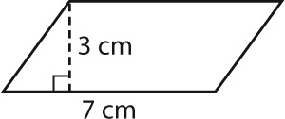   21 cm²
The area of a trapezoid is half its height multiplied by the sum of the lengths of its  two bases.  A  h(b₁  b₂) ÷ 2 | A  h(b₁  b₂) ÷ 2  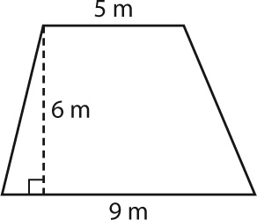   6(5  9) ÷ 2   6(14) ÷ 2   84 ÷ 2   42 m²
The area of a rhombus is half of the product of its two diagonals.  A  d_{1 x} d_{2 ÷ 2} | A  d_{1 x} d₂ ÷ 2  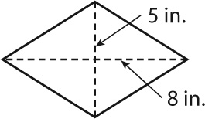   (5)(8) ÷ 2  = 40 ÷ 2   20 in.²

